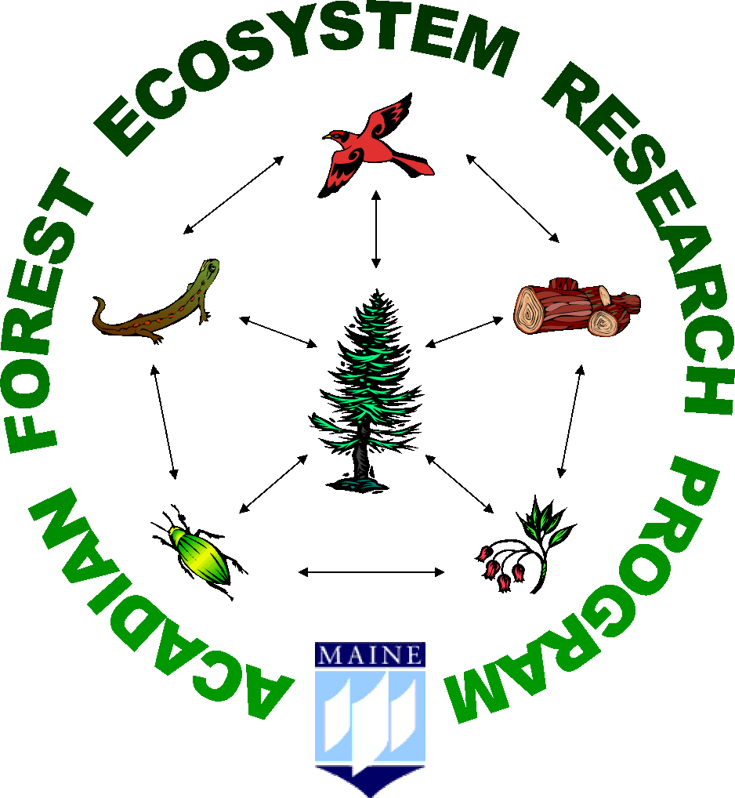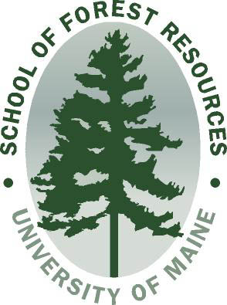

A Brief History of AFERP:
Acadian Forest Ecosystem Research Program

www.forest.umaine.edu/facstaff/facstaff_pages/wagner/FERP/default.html

During the early 1990s, there was a broad movement in forestry to adopt silvicultural regimes that were based on the disturbance ecology of a given region. This movement precipitated a new paradigm, called “New Forestry,” that initially swept through the Pacific Northwest and other western states. In the Northeast, Seymour and Hunter (1992) published the “Triad” concept of forest land allocation; this was an attempt to address many of the biodiversity concerns with traditional forestry systems that were being applied in the region. Under the Triad, the forested landbase was allocated into three major uses: 1) 10-20% reserves, 2) 10-20% production silviculture, and 3) the remaining 60-80 % is treated according to principles of ecologically-based forestry.
The Triad, had one glaring weakness—there were few or no examples of disturbance-based silvicultural systems being studied around the country, including the Acadian Forest Region. Traditional silviculture methods, like those found in the long-term silviculture experiment at the Penobscot Experiment Forest (PEF) (Sendak et al. 2003), had weaknesses that might make them unfeasible for broader management at the landscape scale under an ecological forestry paradigm. Research with hybrid silvicultural systems, hybrids of both even-aged and uneven-aged systems, was needed.
To fill this research niche, the Acadian Forest Ecosystem Research Program (AFERP) was established in 1994. AFERP was designed as an interdisciplinary, long-term research effort that would complement the USDA Forest Service’s experiment at the PEF near Bradley, Maine. AFERP’s mission is to: 1) Enhance understanding about the forest ecology of the Acadian Forest Region; 2) Evaluate ecosystem-scale effects of forest practices; and 3) Explore the potential for developing alternative silvicultural techniques and systems based on regional disturbance ecology. An overarching objective for AFERP is to provide the science that helps landowners develop hybrid systems that combine the economic advantages of even-aged methods with the flexibility to provide many of the structural features found in uneven-aged stands.
Although AFERP is only a teenager, it is currently one of the countries oldest running experiments on the effects of disturbance-based silviculture. Our first sample inventories were taken from 1995-1997 the season before initial harvest treatments were installed. Since then, AFERP has contributed in many ways to UMaine’s overall research infrastructure. For example, AFERP has provided a platform for: 7 graduate research projects, 3 undergraduate capstone projects, and numerous groups on field tours of the experiment. The 3 years form 2005-2007 were milestone years for AFERP during which the first round of gap expansions were installed (2nd entry). These successes would not have been possible without support from many sources including the University Forests Office. With our next measurement cycle rapidly approaching (2010-2012), we look forward to the next 15 years; a period that includes: 3 inventories, harvest entry 3, and the first round of expansions on our small gap treatment.

